**HOUSE OF SANDWICH**

A Business Plan Presented to the

Bachelor of Science in Hospitality Management of

Our Lady of Lourdes College, Valenzuela City

In Partial Fulfillment of the

Requirements of the Subject

Entrepreneurship in Tourism and Hospitality

**Submitted by:**

De Gula, Allen Christian C.Gutierrez, Angelica Rose

Javier, Mary Krezzel C. Madeja, Jhonna Claire L.

Mamado, Marian O. Valdez, John Paul D.

Wagas, Rose Angelica M.

**Submitted to:**

Mrs. Vivian S. Castillo, MBA - HRM

**ACKNOWLEDGEMENT**

**ABSTRACT**

**Title :** House of Sandwich

**A feasibility Study**

**Researchers:**

De Gula, Allen Christian C.

Gutierrez, Angelica Rose

Javier, Mary Krezzel C.

Madeja, Jhonna Claire L.

Mamado, Marian O.

Valdez, John Paul D.

Wagas, Rose Angelica M.

**Degree** : Bachelor of Science in Hospitality Management

**Institution** : Our Lady of Lourdes College – Valenzuela City

**Adviser** : Mrs. Vivian Santos Castillio, MBA-HRM

**TABLE OF CONTENTS**

**Chapter 1.**

* **Introduction**

A. Backgroung of the Study

B. Business Name

C. Business Address

D. Company Logo

E. Vision and Mission

F. Objective of the Study

G. Scope and Delimitation of the Study

H. Business Ownership Type

**Chapter 2**

* **Market Study**

A. Analysis of Competitors

B. Markket Segmentation

C. Marketing Strategies and Techniques

**Chapter 3**

* Technical Study

A. Objective of the Study

B. Product and Services

C. Menu Planning and Costing

D. Operation Schedule

E. Machinery and Equipment

F. Location

G. Layout and Design

H. Source of Raw Materials and Supplies

I. Serving Procedure

J. Utilities

K. Waste Disposal Management

**Chapter 4**

* Management Study

A. Form of Business Ownership

B. Capitalization

C. Organizational Structure

D. Job description and Job Requirments

E. Employee’s Schedule and Manpower Schedule

F. Compensation

G. Organization Policies

H. Legal Requirments

**Chapter 5**

* **Financial Study**

A. Total Project Cost

B. Initial Capital Requirments

C. Sources of Financial

D. Financial Statements

**Chapter 6**

* **Socio-Economics Plan**

A. To the Government

B. To the Environment

C. To the Community

D. To the Customers

**Appendices**

* Appendix A
* Appendix B
* Appendix C
* Appendix D

**Resume**

**Chapter 1**

**INTRODUCTION**

**A. Background of the Study**

House of Sandwich is a kiosk type of business, which aims to provide diffirent variety of flavors starting with Korean sandwiches. The main inspiration was by famous kinds of sandwiches in Korea, the thick, flavorful and full of elements in just 1 serving of Sandwich. In addition, as their culture influences the current generation the aspiring owners wanted to bring the taste and vibe here in the Philippines.

Furthermore, the House of Sandwich are serving only in take-out and offering drinks and sides to collaborate with the sandwiches. In order to scope the market we are not proving only on the perpective of the majority but also to provide for health - conscious people and sweet lover people in the near future.

It is Located in SM Grand Central, Caloocan City and the possible Target market is the students from high school students, Shs students, Collages, Employeed, Senior citizen, business owner and worker even the Person with disability (PWD) who enter the establishment of Mall premises.

**B. Business Name**

The Business name is House of Sandwich. It named after to its main goal, to make and provide different kinds of sandwiches. The word “House” is inspired in Filipino culture, who always wanted to open their houses to accommodate and serve for their beloved visitor and the word “Sandwich” is name after the product itself.

**C. Business Address**

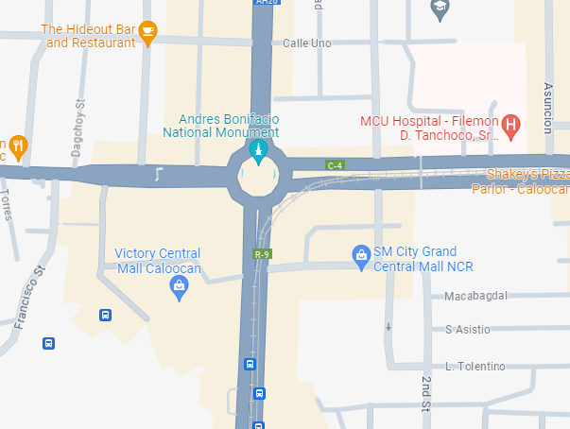Grand Central Mall, 2nd floor main building Rizal Ave Ext, East Grace Park, Caloocan City, Metro Manila. The estimated Time Travel from Our Lady of Lourdes College is 15 minutes as of February 1, 2024.

**D. Company Logo**

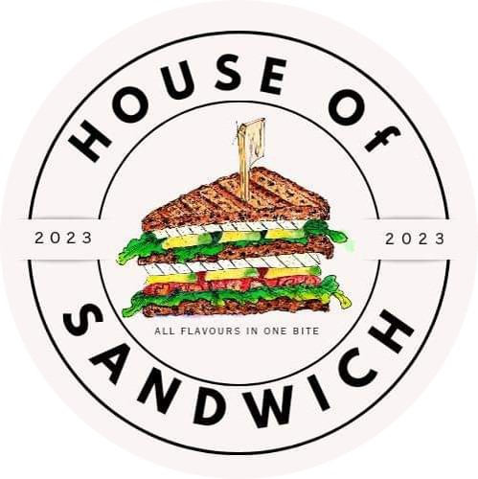

The Logo itself are consisting four categories, which can be determine the meaning of logo in easy way. The Business name, Company EST, Tagline, and Sandwiches in the middle.

It has white backgroup that represent cleanliness, black for letters and font. Sandwich itself since it is the product offered and for them to be able to identify the product offered in just one look without reading the business name. Moreover, Circle represent the accommodation of House of Sandwich to its costumer.

**E. Vision**

Our vision is to provide variety of choices for our customers, in order to satisfy their cravings. To create an exceptional flavor that can exceed their own expectations and can imprint a great impression on their minds.

**Mission**

Our mission is to provide flavorful, delicious, and tasty variety of sandwiches that are suited for cravings. We strive to offer the greatest service, value, and accomodation. To handle our customers needs, complaints, and request with full enthusiasm and with great passion and dedication.

In order to achieve this, the employees and management of House of Sandwich commit themselves to:

* Everyone must have an enjoyable experience by providing good customer service. This means paying attention to their complaints, needs, and requests.
* The House of Sandwich prioritizes workers growth, their well-being, and fulfillment through their fair wage, benefits, exclusive working environment, advancement opportunities, and a safe working environment.

**F. Objective of the Study**

In providing a feasible travel agency business, specially, the objectives of the Study.

* Price: - Analyze competitor-pricing strategies to set competitive prices that cover ingredient and operational costs while maintaining profitability. Consider consumer perception of value and willingness to pay when determining the pricing strategy. Implement pricing tactics such as bundle deals or loyalty programs to attract customers and maximize revenue.
* Product Appearance - Design sandwiches with visually appealing ingredients and presentation to stimulate customer interest and appetite. Invest in high-quality packaging and display methods to highlight the freshness and quality of the sandwiches. Incorporate branding elements into the product presentation to enhance brand recognition and customer loyalty.
* Product Marketability - Conduct market research to identify consumer preferences, dietary trends, and flavor profiles to tailor the sandwich offerings accordingly. Develop a unique selling proposition (USP) or specialty sandwiches that differentiate the kiosk from competitors and appeal to target customer segments. Utilize marketing channels such as social media, signage, and promotional events to communicate the value proposition and generate buzz around the product offerings.
* Place of Distribution - Evaluate potential kiosk locations within SM Grand Central Valenzuela based on foot traffic, visibility, and accessibility to target customers. Negotiate lease agreements and ensure compliance with zoning regulations and health codes for the selected location. Establish efficient supply chain management processes to ensure timely delivery of ingredients and minimize operational disruptions.

To assest the Feasibility of House of Sandwich in Terms of:

* Market Aspect - Analyze market demand for sandwiches through surveys, interviews, and competitor research to understand consumer preferences and purchasing behavior. Identify target customer demographics, including age, income, and lifestyle factors, to tailor marketing strategies and product offerings effectively. Monitor market trends and adapt the business strategy accordingly to capitalize on emerging opportunities and mitigate risks.
* Technical Aspect - Assess equipment needs for food preparation, storage, and display, ensuring they meet operational requirements and regulatory standards. Implement food safety protocols and hygiene practices to maintain cleanliness and prevent contamination in the kiosk. Train staff on proper equipment usage and food handling procedures to ensure product quality and customer satisfaction.
* Management Aspect - Develop staffing plans, including hiring, training, and scheduling, to ensure adequate coverage during peak hours and efficient operations. Establish clear roles and responsibilities for employees and implement performance metrics to monitor productivity and customer service standards. Foster a positive work culture and provide ongoing training and development opportunities to motivate staff and improve retention.
* Financial Aspect - Calculate start-up costs, including equipment purchases, permits, and initial inventory, to determine the initial investment required to launch the kiosk. Project revenue streams based on sales forecasts, pricing strategy, and market demand to estimate future profitability and return on investment. Develop financial projections and contingency plans to manage cash flow, mitigate risks, and ensure the long-term financial sustainability of the business.

**G. Scope and Delimination of the Study**

The feasibility study, House of Sandwich covers the area in SM Grand Central, wherein the primary target market is individuals, business people, employees, students and those who shop in the area. Fifty respondents will be surveye. The researchers will use the available resources, such as survey questionnaires with the target respondents, to reach an appropriate target market that will use the service.

**H. Business Ownership Type**

The Aspiring Business Owner decided to select the Business Ownership type into Partnership, which consist of seven People who can manage and carry out each duties. In Addition, make plans for the future, increase knowledge about products, strategies, and trends. Business partner relationships serve as crucial links and resources that comes with its own set of advantages and disadvantages. As a product or service evolves or when a new product or service is required, developing ties with potential business partners can be helpful.

**Chapter 2**

**MARKET STUDY**

**A. Analysis of Competitors**

**B. Market Segmentation**

**C. Marketing Strategies and Techniques**

**a. Marketing Mix**

**Product**

* Offer a diverse menu of freshly prepared sandwiches, including Chicken tender sandwich, Egg fried Garlic toast and Gilgeori, as well as unique creations with premium ingredients and innovative flavor combinations.
* Ensure consistent quality and freshness by using high-quality ingredients sourced from trusted suppliers.
* Introduce seasonal specials or limited-time offers to keep the menu exciting and encourage repeat visits.

**Place**

Grand Central Mall, 2nd floor main building Rizal Ave Ext, East Grace Park, Caloocan City, Metro Manila.

* Leverage the prime location at SM Grand Central to attract foot traffic from shoppers, office workers, and visitors to the mall.
* Ensure a convenient and efficient ordering process for takeout customers, with clear signage and a well-organized counter area.
* Offer online ordering and delivery services through popular food delivery platforms to reach customers beyond the mall premises and capitalize on the growing trend of food delivery.

**Price**

**Sandwiches**

|  |  |
| --- | --- |
|  | **Price** |
| Egg fried garlic toast | ₱190.00 |
| Chicken tender | ₱288 .00 |
| Gilgeori toast | ₱143.00 |

**Drinks**

|  |  |
| --- | --- |
|  | **Price** |
| Coke | ₱55.00 |
| Sprite | ₱55.00 |
| Royal | ₱55.00 |
| Brewed Coffee | ₱37.00 |
| Water | ₱20.00 |

**Sides**

|  |  |
| --- | --- |
|  | **Price** |
| French Fries | ₱42.00 |

**Combos**

|  |  |  |  |
| --- | --- | --- | --- |
|  | **Combo 1**  (Sandwich with Drinks) | **Combo 2**  (Sandwich with Sides) | **Combo 3**  (Sandwich With Sides and Drinks) |
| Egg Fried Garlic Toast | ₱240.00 | ₱230.00 | ₱285.00 |
| Chicken Tender | ₱340.00 | ₱325.00 | ₱380.00 |
| Gilgeori Toast | ₱195.00 | ₱180.00 | ₱235.00 |

**Promotion**

**Before the Operation**

* Promote and Boost through all Social Media Platforms Such as Facebook, Instagram, etc.
* Flash or put a Tarpaulin at the entrance of mall indicating the events, location and promotional price or things to benefit.
* Assign people to spread the Flyers with voucher stab. Voucher will handover once the customer register for the upcoming opening of the store.

**During the Operation**

* The Designated employee will intertain the orders of customer.
* Customer with voucher and without voucher are ask by the assign employee for additional and upgrade orders.
* Customers will observe how their product prefer.

**Promotion/Advertisement costing**

|  |  |  |  |
| --- | --- | --- | --- |
| **ITEMS** | **UNIT** | **PRICE** | **TOTAL** |
| TARPULIN | 2 | 150 | 300 |
| FLYERS | 200 | 3 | 600 |
| MENU | 3 | 25 | 75 |
| INVITATION | 20 | 25 | 500 |
| BALLOONS |  |  | 800 |
| COMPLIMENTARY FOODS |  |  | 2500 |
|  |  |  | TOTAL: 4,775 |

Every anniversary the company will priviledge 30 costumers for discounts and freebies. The product are promote by using flyers to be accessible on social media accounts and on the physical store.

**b. Strength, Weakness, Opportunities, and treats (SWOT)**

**Strength**

* Unique and innovative sandwich recipes that set "House of Sandwich" apart from competitors.
* High-quality ingredients sourced from local suppliers, ensuring freshness and flavor.
* Strong brand reputation and customer loyalty due to consistent delivery of delicious sandwiches.
* Strategic location in a high-traffic area, attracting a steady flow of customers.

**Weakness**

* Limited marketing efforts and brand visibility, resulting in lower customer awareness.
* Inconsistent service quality during peak hours, leading to customer dissatisfaction.
* Reliance on a small menu selection, potentially limiting customer choices and preferences.
* Lack of online ordering and delivery options, missing a growing market segment.

**Opportunities**

* Collaborations with local food bloggers and influencers to increase brand exposure and reach a wider audience.
* Expansion of the menu to include vegetarian, vegan, and gluten-free options to cater to diverse dietary preferences.
* Implementation of a customer loyalty program to incentivize repeat business and foster customer retention.
* Integration of online ordering and delivery services to tap into the convenience-driven market.

**Threats**

* Intense competition from established sandwich chains and local eateries offering similar products.
* Fluctuating ingredient prices and supply chain disruptions that may affect profitability.
* Changing consumer preferences and trends that may require constant menu innovation.
* Economic downturns or recessions that could affect consumer spending on dining out.

**Chapter 3**

**TECHNICAL STUDY**

1. **Objective of the study**

House of Sandwich aims to provide different variety of sandwiches, giving customers a chance to choose their best choice. The main inspiration was by famous kinds of sandwiches in Korea and as their culture influences the current generation we wanted to bring the taste and vibe here to the Philippines. In order to scope the market we are not proving only on the perpective of the majority but also to provide for health - conscious people and sweet lover people in the near future.

1. **Product and Services**

House of Sandwich aims to provide different variety of sandwiches starting with Chicken tender sandwich, Egg fried Garlic toast and Gilgeori also known as street toast. The product will be served in safe packaging with sealed and tissue. The kioks was Located at Grand Central Mall, 2nd floor main building Rizal Ave Ext, East Grace Park, Caloocan City, Metro Manila

**Main Product offered and its ingredients:**

CHICKEN TENDER SANDWICH - Sliced bread, BBQ sauce, Tomato, lettuce, finger

Chicken, Carrots, Honey mustard sauce

EGG FRIED GARLIC TOAST - Toasted bread, Cheddar cheese, scrambled egg &

Sunny side up, Bacon, Garlic Mayo

GILGEORI - Toasted bread, ketchup, mayonnaise, sliced ham **mixture**: carrots, cabbage, scallion, egg, and butter

We offer a menu which can be seen the types of sandwiches offered and the definition of each sandwich including the combos and solo orders. The Kiosk is located in a mall area where the co-kiosk owner and food stall owner sell their products; the store is for take-out only. Since the type of business is a kiosk, where there is a specific place to rent, the customer will have the privilege to witness how the assigned Employee prepares their food. For good advancement, they also have a chance to suggest add-ons depending on their preferences.

The add-ons will be the sauces with additional payment. Drinks will see on a menu because solid food needs liquid to collaborate with and sides, which is French fries for better. The menu are divided into 6 categories: Alacarte, sandwich with French fries, Sandwich with drinks, Sandwich with French Fries and Drinks Soda’s in can and Add ons. These Product appear in menu Board or Monitor at the upper part of counter, it is easy for them to see the Prices of each product offered and also to lessen the interaction between costumer and employee therefor Many possible costumer will be accommodate and intertain.

The store crew or employee should be at least 2 people to divide the task Including the cleaning operation and the gap when it should be changed and cleaned. For organizational purposes, there will be two sides for taking orders, which is on the left side, and receiving orders, which is on the right side to avoid missed call-outs.

Will have a quote of the Day to inspire people outside, it can be a word of encouragement and something that boasts people to work hard and do their very best in every day they have. Our Generation should lift up each other for a better future and we should set an example because some people do the same thing because they are inspired so, be an example and inspiration to others.

1. **Menu planning and costing**
2. **Purchasing Receiving and Storage Handling**

The ingredients are all from the markets around Phillipines and all ingredients are available in our current market whether public market/wet market or supermarkets. The store will do inventory every other day for example; Monday, Wednesday, Friday and Sunday to ensure that all products offered will be provided and to avoid marking them as not available. In addition to secure, that all ingredients are fresh and in good condition every time the store operates.

There will be a storage where all the stocks are stored. Freezer Storage for meats like Bacon, Ham, and Chicken ranges from 10°F to be able to preserve the life of meats. Refrigerator Storage for vegetables, sauces, and drinks temperature ranges to 35°F and for dry storage where the breads sachet sugar etc. are stored it should be ranges in 50-70 °F. The importance of proper storage is to help to preserve the quality and nutritional value of each products and ingredients, in addition is to prevent foodborne illness caused by harmful bacteria that can affect the health of your costumer.

For Ready Made Sandwiches it should place over 140°F in the Food Warmer to keep the bacteria at bay.

1. **Menu Planning and Costing**

House of Sandwich Offered Sandwiches starting with Chicken Tender, Egg Fried Garlic Toast, and Girlgeori known as Street Toast in Korea. Not Just Sandwiches but Drinks like Sodas and Coffee offered for the whole Operting hour and sides, which is the French Fries, also add ons available for Sauces.

We place a description in each sandwiches for them to be able to determine the ingredients. **Menu:**

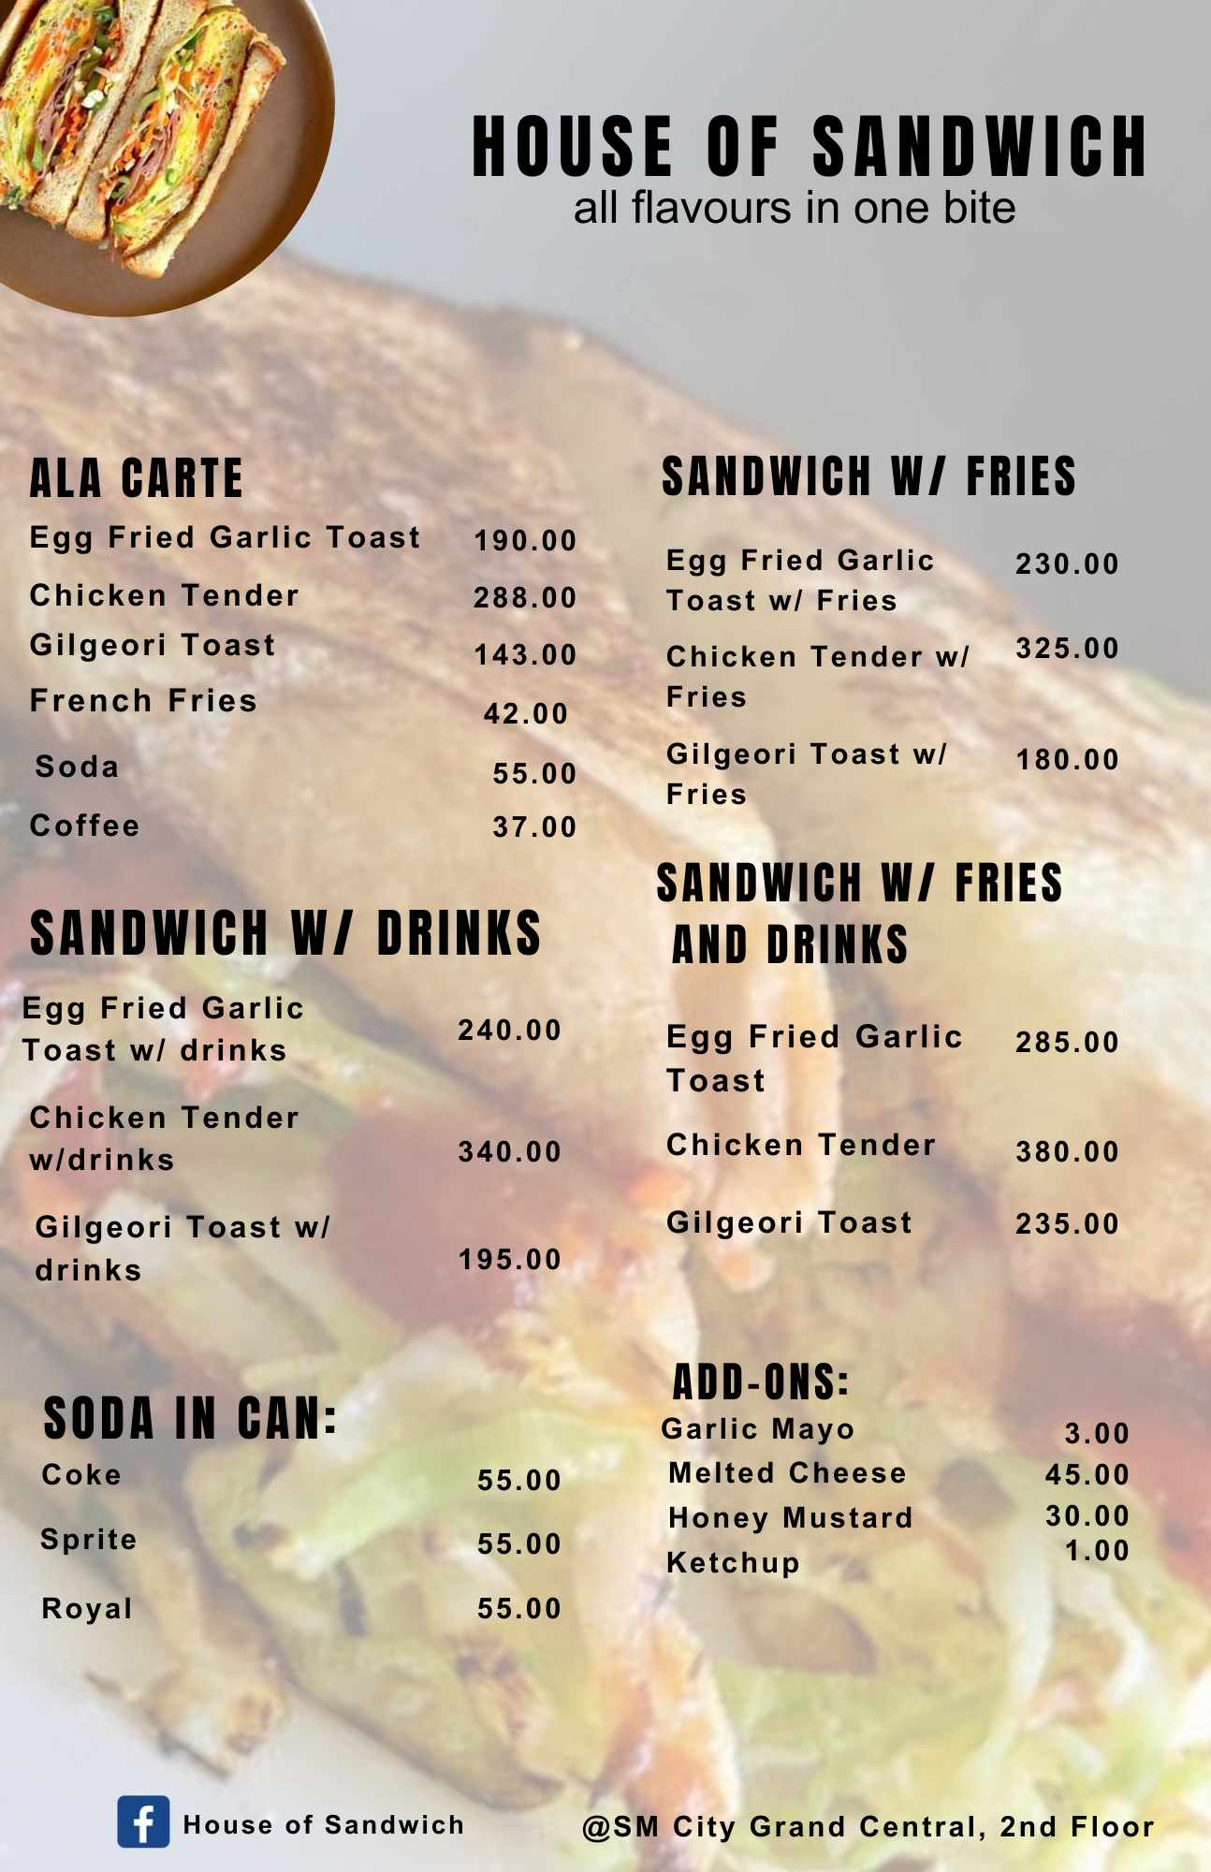

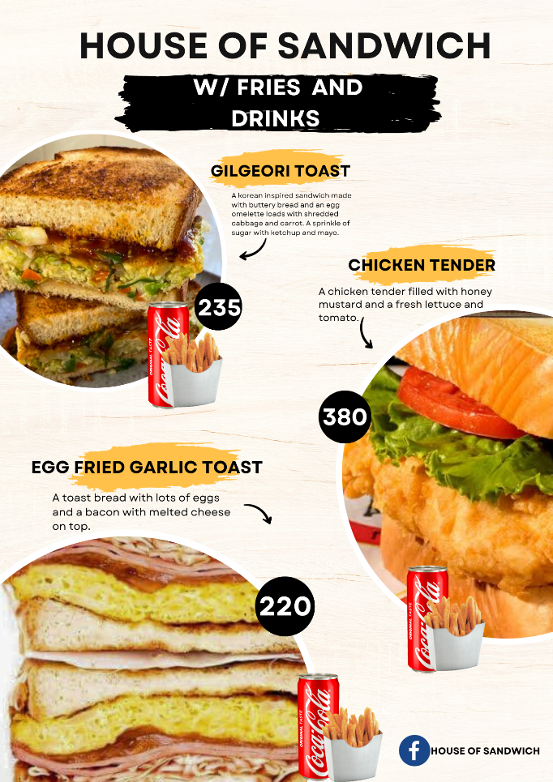

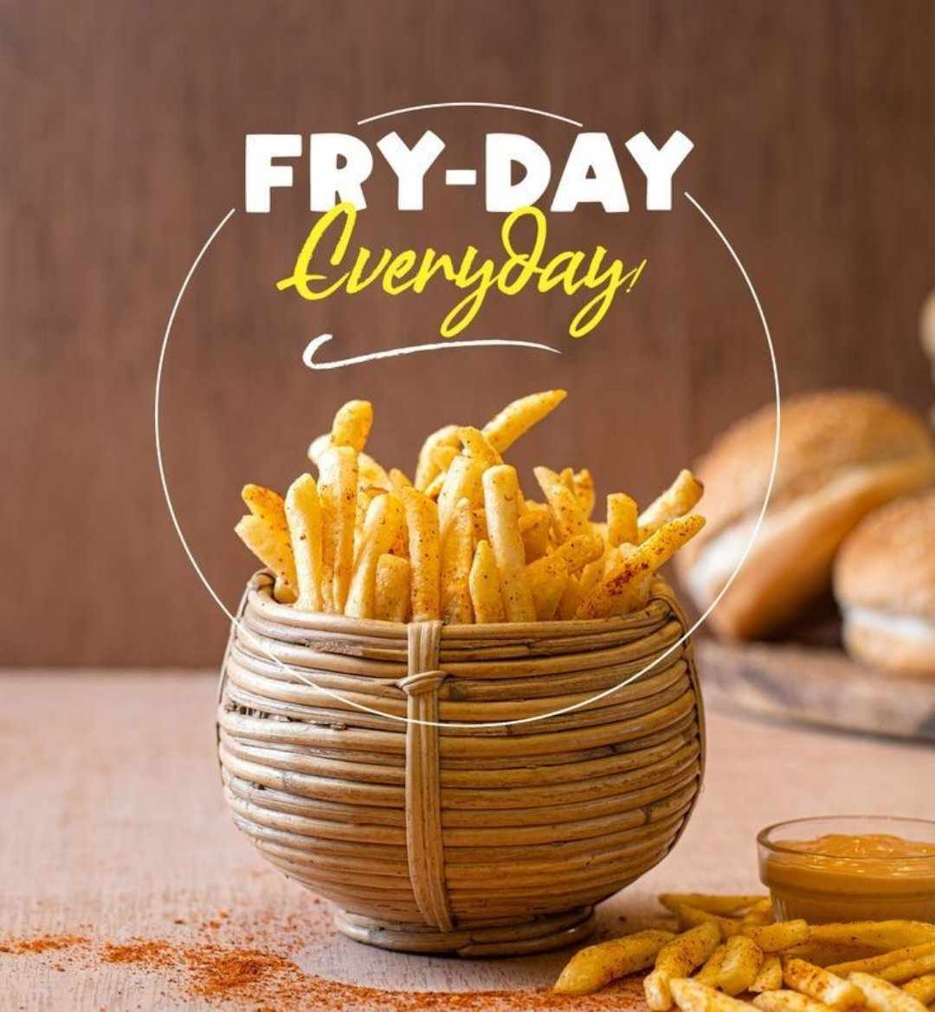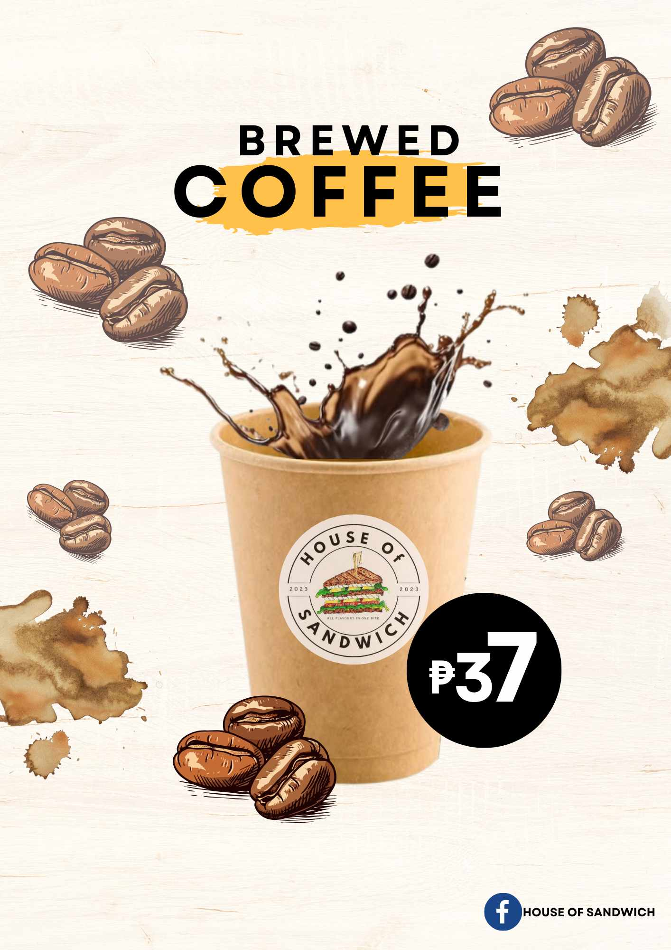

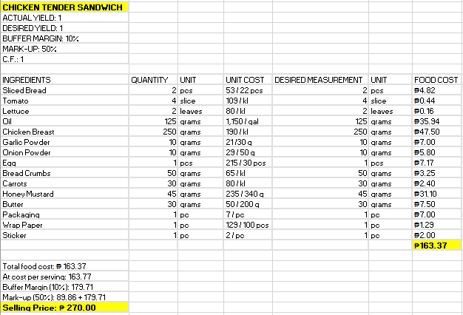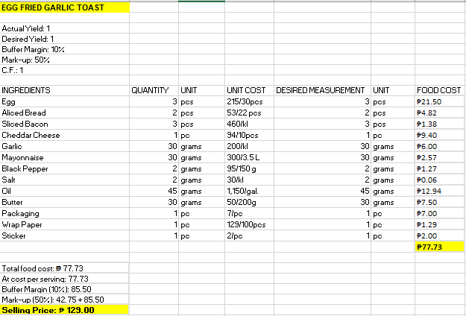**Costing: Alacarte/solo**

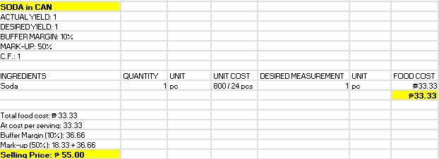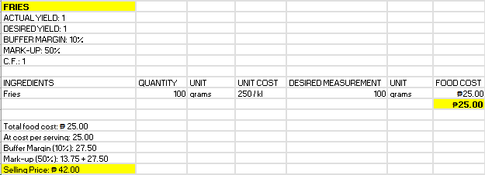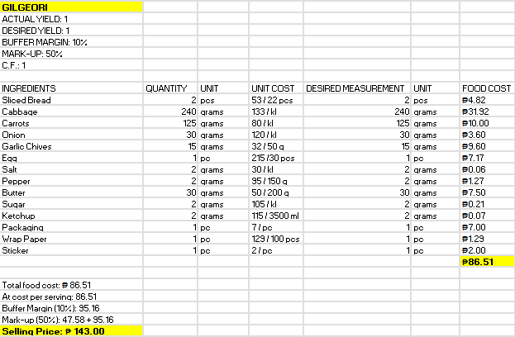

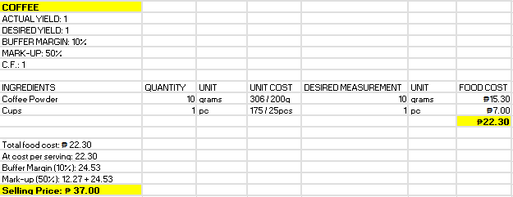

**Sandwich with Fries**

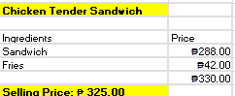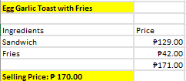

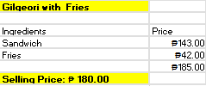

**Sandwich with Drinks**

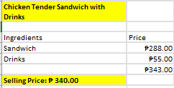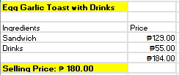

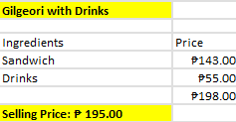

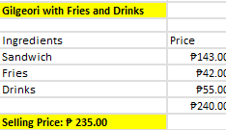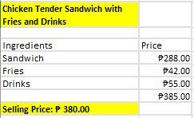**Sandwich with Fries and Drinks**

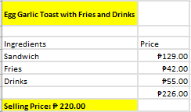

1. **Operating Schedule**

We the entrepreneurs select the operations and schedule of the House of Sandwich at Sm Grand Central. The store will operate from 10 am to 9 pm total of 11 hours a Day, Equivalent to Mall hours. It was decide that this is the opening and closing time of our store because the sandwich can be the starter of morning as breakfast, lunch and dinner in addition for snacks; it depends on the customers if they want. The house of Sandwich is open from Monday to Sunday for the satisfaction of our customers.

30 minutes ahead of mall hour are required for the operation hour to prepare for the opening of the store same as in closing employee should always have 30 mins for cleaning

Example of Employee’s Schedule:

|  |  |  |  |
| --- | --- | --- | --- |
| **Name** | **Time in** | **Break** | **Time Out** |
| Jhonna Madeja | 9:30 Am | 1:30 Pm – 2:20 Pm | 6:30 Pm |
| Allen De Gula | 1:30 Pm | 5:30 pm – 6:30 pm | 10:30Pm |

These two employee should meet in the middle of their schedule to balance the working station and sales. One of them will assigned during opening hour and the other during closing hour.

1. **Machineries and Equipment.**

**a. Take-Out Equipment**

|  |  |  |  |  |
| --- | --- | --- | --- | --- |
| **ITEM** | **IMAGE** | **QUANTITY** | **UNIT PRICE** | **PRICE** |
| Square Box | 20PC Transparent cake sandwich box packaging sandwich gift box square cake  box kraft paper box | Lazada PH | 10 Pcs | ₱ 7.00 | ₱70.00 |
| Wax Paper | 50 Pcs Oilproof Food Paper Baking Paper Parchment Candy Wrapper Hamburger  Wax Paper, N : Amazon.co.uk: Home & Kitchen | 100 pcs | ₱ 129.00 | ₱129.00 |
| Tissue |  | 1,000 sheets | ₱ 0.049 | ₱49.00 |
| Coffee Cups |  | 25 pcs. | ₱7.00 | ₱175.00 |
| Paper Bag |  | 100pcs | ₱1.65 | ₱165.00 |
| Scotch Tape | Crocodile Scotch Tape 24mm X School & Office Use | Lazada PH | 1pc |  | ₱21.00 |
| Tape Dispenser | Scotch Heavy-Duty Dispenser - Holds Total 1 Tape(s) - 3" Core - Refillable  - Beige - 1 Each - Tape Dispensers | 3M | Total Office Solution of West  Texas | 1 pc |  | ₱96.00 |
| Plastic Gloves | 100pcs/Pack Disposable Gloves One-off Plastic Gloves For Food Cleaning  Cooking kitchen accessories | Lazada PH | 100 pcs | ₱1.67 | ₱60.00 |
| **TOTAL** |  |  |  | **₱765** |

**b. Kitchen equipment**

|  |  |  |  |  |
| --- | --- | --- | --- | --- |
| Electric Griller | Electric burger Grill 220 V : Buy Online at Best Price in KSA - Souq is now  Amazon.sa: Patio, Lawn & Garden | 1pc |  | ₱7,000.00 |
| Electric Double  Deep Fryer | 5000W 12L Stainless Steel Electric Deep Fryer Dual Tank Commercial  Restaurant | eBay | 1pc |  | ₱7,500.00 |
| Coffee Maker | Stainless Steel Coffee Maker with 2 Liter Thermal Carafe – Omcan | 1 pc |  | ₱1,169.10 |
| Microwave | Buy Samsung 30L Microwave Grill Oven online | Samsung Philippines | 1pc |  | ₱4,990.00 |
| Sink | angelHJQ Handmade Undermount Single Bowl,Stainless Steel Kitchen Sink,  Corrosion, Scratch and Rust Resistance,Top Mount/Drop-in,50 * 40cm :  Amazon.co.uk: DIY & Tools | 1 pc |  | ₱2,599.00 |
| Reverse osmosis |  | 1 pc |  | ₱10,063.00 |
| Exhaust Fan |  | 1 pc |  | ₱1,744.00 |
| Dishwashing liquid | Dishwashing liquid detergent in plastic bottle. Green color dishwashing  liquid Stock Photo | Adobe Stock | 1 L |  | ₱45.00 |
| Foam | Dishwashing Double-Sided Sponge With Non-Scratch Soft Spongy Absorbent Foam  Strong Water Absorption Sponges For Washing  Dishes/Kitchen/Bathroom/Bathtub/Tiles | Lazada PH | 12 pcs |  | ₱99.00 |
| Trash Can | Kit Including Top Mount Soft Close Single or Double Trash Can Unit with 35  Quart or 50 Quart Trash Can, Minimum Cabinet Opening: 12", 15", 18" or 21"  Wide by Hardware Resources | | 2 pcs | ₱149.00 | ₱298.00 |
| Carbage Bag | Garbage Bag – donewellplastics | 100 pcs | ₱1.39 | ₱139.00 |
| Coffee filter | Commercial Coffee Filters: in Bulk at WebstaurantStore | 100 pcs | ₱0.86 | ₱86.00 |
| **TOTAL** |  |  |  | **₱35,734.1** |

**c. Stortage Equipment**

|  |  |  |  |  |
| --- | --- | --- | --- | --- |
| Refrigerator |  | 2pcs | ₱11,998 | ₱23,996 |
| Containers | NewTupperware Large Snack N Stor Food Container - Lilac : Amazon.de: Home &  Kitchen | 1 set | ₱350.00 | ₱350.00 |
| Chiller |  | 3pcs | ₱10,484 | ₱31,452.00 |
| Water gallon | 12,000+ Water Gallon Stock Photos, Pictures & Royalty-Free ... | 2 pcs | ₱155.00 | ₱310.00 |
| **TOTAL** |  |  |  | **₱56,108.00** |

**d. Food Preparation equipment**

|  |  |  |  |  |
| --- | --- | --- | --- | --- |
| Knife | The anatomy of a knife | BBC Good Food | 1 pc | ₱80.00 | ₱80.00 |
| Grater | K BASIX Professional Box Grater for Kitchen, 4 Sided Philippines | Ubuy | 1 pc | ₱73.00 | ₱73.00 |
| Scissors | 4-in-1 Multipurpose Kitchen Shears - Kitchen Pro | 1 pc | ₱30.00 | ₱30.00 |
| Chopping board | 12” x 18” x ¾” Cutting Boards Contains 3 Boards, 1-RED, 1-WHITE &amp;  1-GREEN | eBay | 1 pc | ₱160.00 | ₱160.00 |
| Tong | PRIME BAKER Homeware Utility Tong for Kitchen Tong for Frying Tong for  Cooking Tong for Serving 10 cm Ice, Sugar, Cake, Sandwich, Roasting Tongs  Price in India - Buy PRIME BAKER Homeware | 1 pcs | ₱25.00 | ₱25.00 |
| Bottle Squeezer | Grilltider Squeeze Bottle 330ml - 2pcs - Furniture Source Philippines | 1 pc | ₱51.00 | ₱51.00 |
| Spatula |  | 1 pc | ₱33.00 | ₱33.00 |
| Pitcher | SP SCIENCEWARE, 5,000 mL Labware Capacity - Metric, 10 mL Graduation  Subdivisions, Graduated Pitcher - 21TP32|F28990-0000 - Grainger | 1 pc | ₱128.00 | ₱128.00 |
| Kitchen towel | Lavish Home Multi-Color Kitchen Icon Design Chic Pattern Weave Cotton Kitchen  Towel Set (8-Pieces) 69HD-008KT - The Home Depot | 1 set | ₱77.00 | ₱77.00 |
| **TOTAL** |  |  |  | **₱657.00** |

**e. Store Equipment**

|  |  |  |  |  |
| --- | --- | --- | --- | --- |
| POS |  | Complete Set |  | ₱50,061.39 |
| Monitor | Led Menu Board Illuminated Ultra Slim Light Box Display • Lindo Signage | 3 pcs | ₱1,476.00 | ₱4,428.00 |
| Food Warmer | Stainless Steel Display Food Warmer 3 - F&C Commercial Kitchen Equipment  Manufacturer in Sabah, Malaysia | FnC Steel Kota Kinabalu, Sabah | Supplier | 1 pc |  | ₱17,000.00 |
| **TOTAL** |  |  |  | **₱71,489.39** |

1. **Location**

SM Grand Central Mall, 2nd floor main building Rizal Ave Ext, East Grace Park, Caloocan City, Metro Manila.

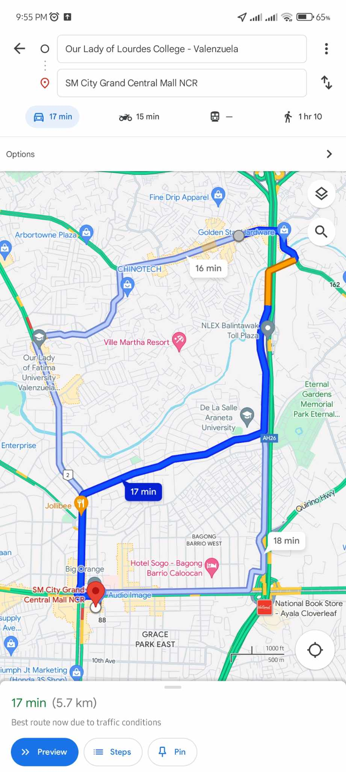

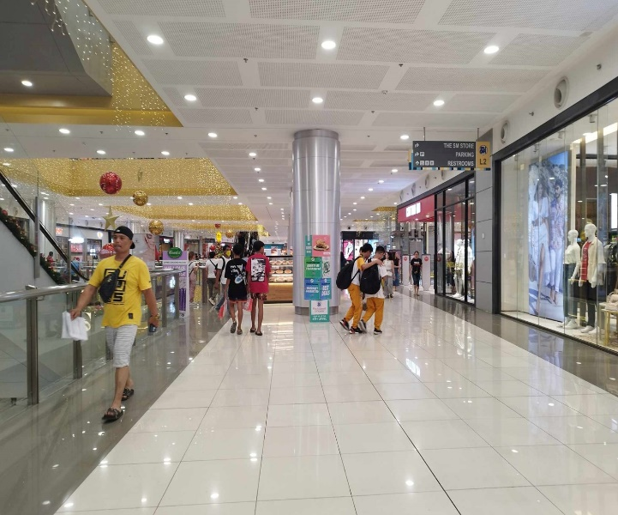

17 Minutes travel from Our Lady of Loudes College.

**G. Lay-Out and Design**

**a. Floor plan, Size, Settings and Design**

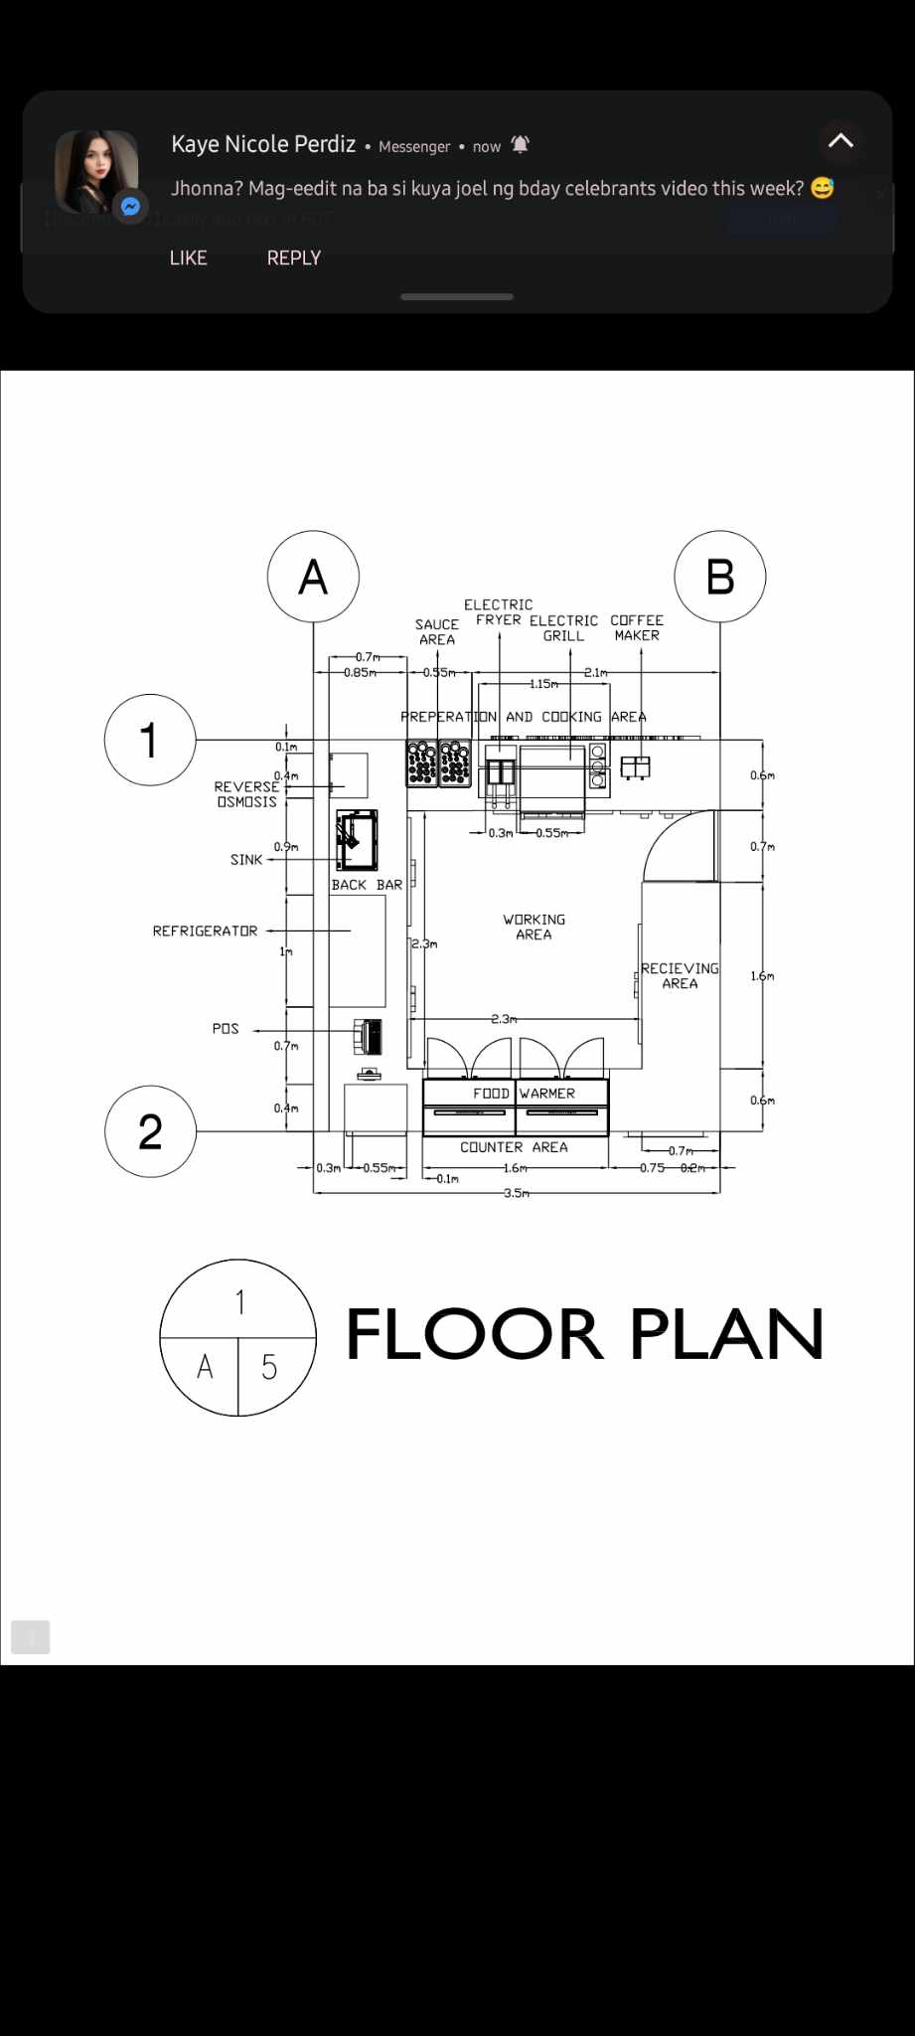

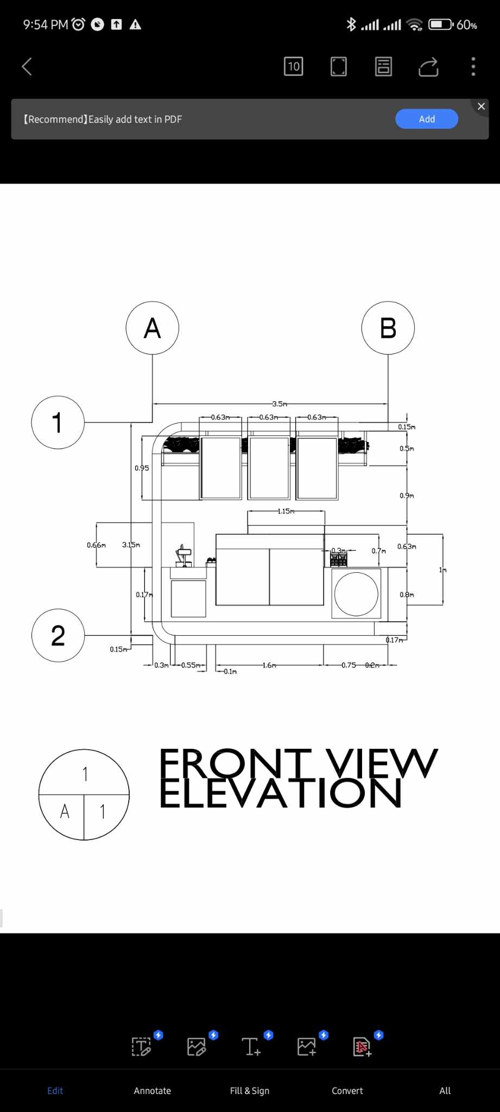

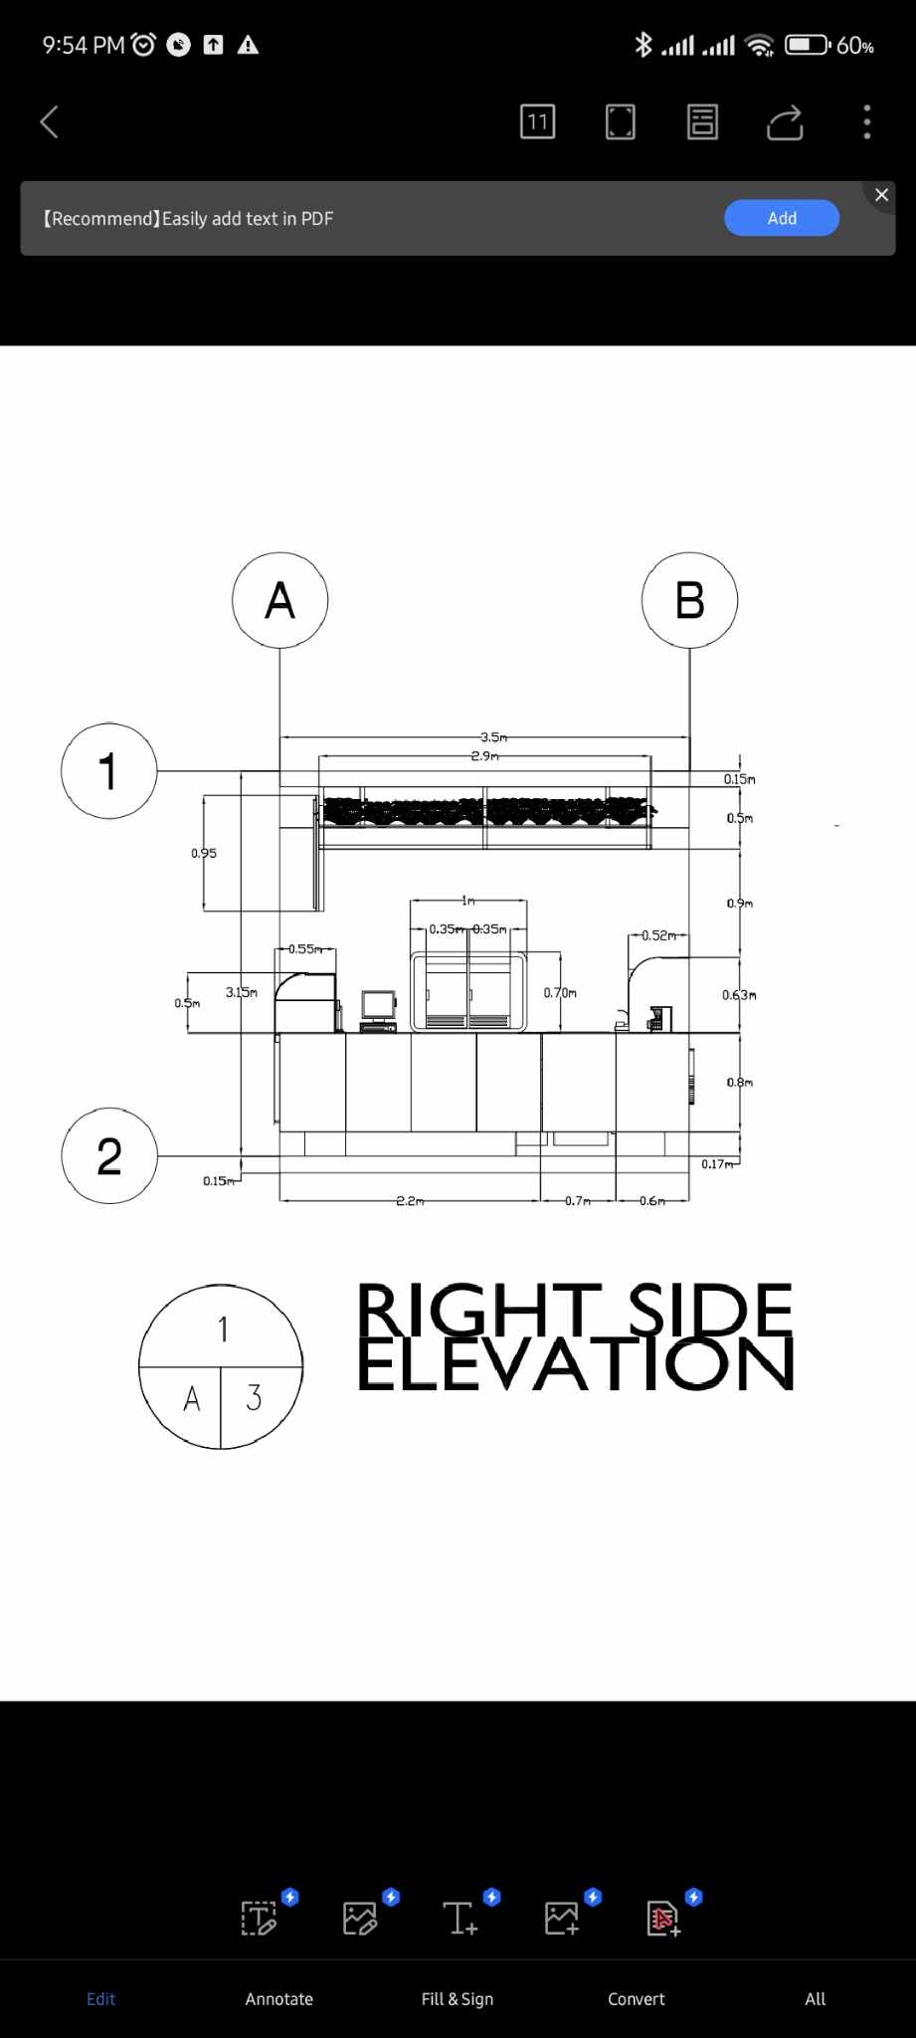

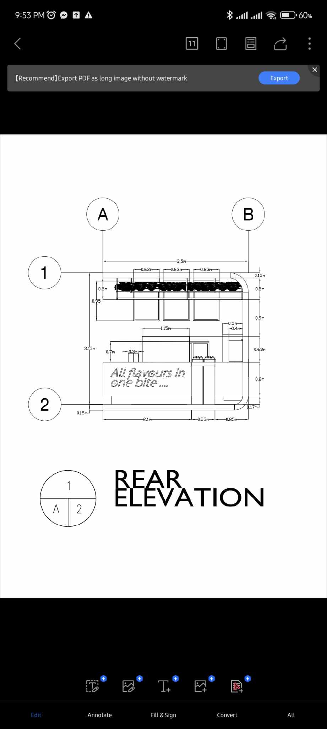

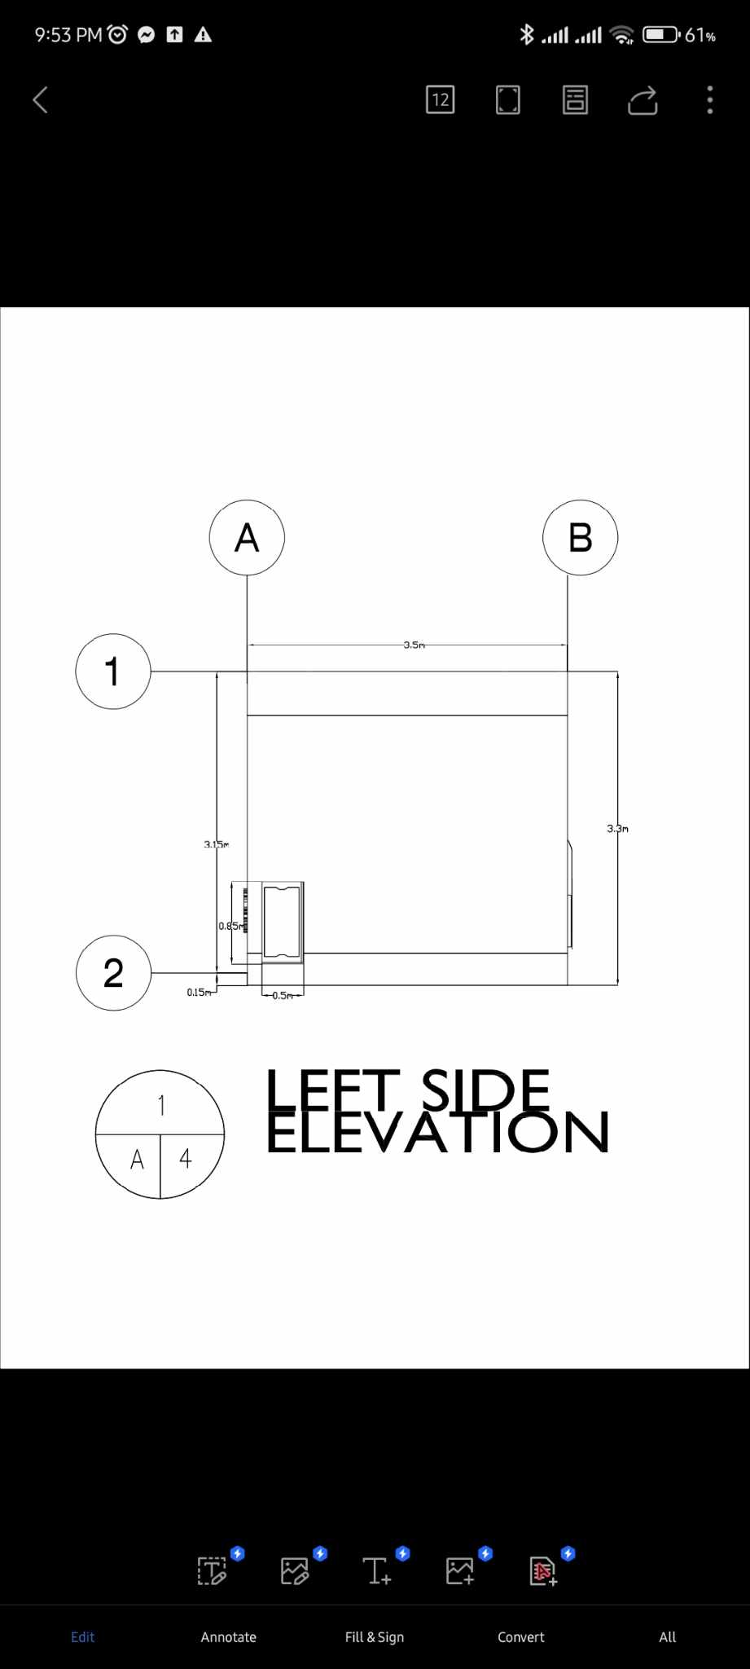

The Floor Plan is 3.5m x 3.5m and the working area are 2.5m x 2.5m. It is located in an open space facing the hallway and besides escalator where people can easily see the Store. First, they will see the freshly made Sandwiches display in our food Warmer and the open area of our Store with high ceiling founded by the Wall and ceiling covered by artificial plants. The purpose of plants is to cover the Steel frame and the Ligths itself not the light coming from it.

The Wall called back bar where the sodas and drinks are located, the upper part are place of Business Name in Acrylic Material with White lights. The lower Part of Chiller of sodas and Drinks There is POS, Sink, and the Reverse osmosis. The Reverse osmosis is machine that Recycle the water therefor, the worker can wash their hands, drink or clean the material they needed immidietly without hesitation in water supply. The Water is coming from the Gallon place under where the Reverse osmosis, the water will pump and process by the machine and coming out to the faucets and this water are also edible and cannot harm the human health. Under of these there is a cabinet where the stocks and room for trashcan.

For the Front view there is a Monitor in the upper part of the counter where the product offered appear and its prices. In the left side theres a Staff that accommodate the costumer and help to determine their product choice easily. Also there is some Sandwiches display at the warmer, they can avail those sandwiches anytime and in the counter area where their order verified and punch by the staff at the sametime that is also the place were the payment and receiving change happen.

At the same area the logo of the store place in the right side area and the promotional picture of the French fries in the left side.

After that, the costumer will assist to move a little bit at the receiving area to wait while the staff assemble their orders. The take-out equipment and material are in the lower part of the receiving area stored and place to be able to present the product faster. If the product choice are not available in the warmer it will be place as Made to order.

The Receiving area are the place where the costumer wait while their product assemble by the Staff, also between receiving area and preparation/cooking Area there is a door for the entrance and exit of the Staff. The Preparation / Cooking area have Electric deep Fryer at the left side and Electric Griller at the right side and the smoke coming from it are secured by tempered glass to be able to compress the smoke when the orders preparing and absorb by exhaust fan. The spot where the smoke absorb is in the rectangular hole with grill cover and process by the machine under of it. Besides of these are the coffee maker machine, it place there because it is hot and for safety precaution of the staff. Also to serve faster.

In the outside View, we can locate the tagline of the business, which is “All Flavours in one bite” in the acrylic material with white light same as the material used in the business name in the wall area.

Behind The Wall or Back Bar, There is a small door and inside of it is the Gallon of Water connected to reverse osmosis.

**b. Perspective View of Interior**

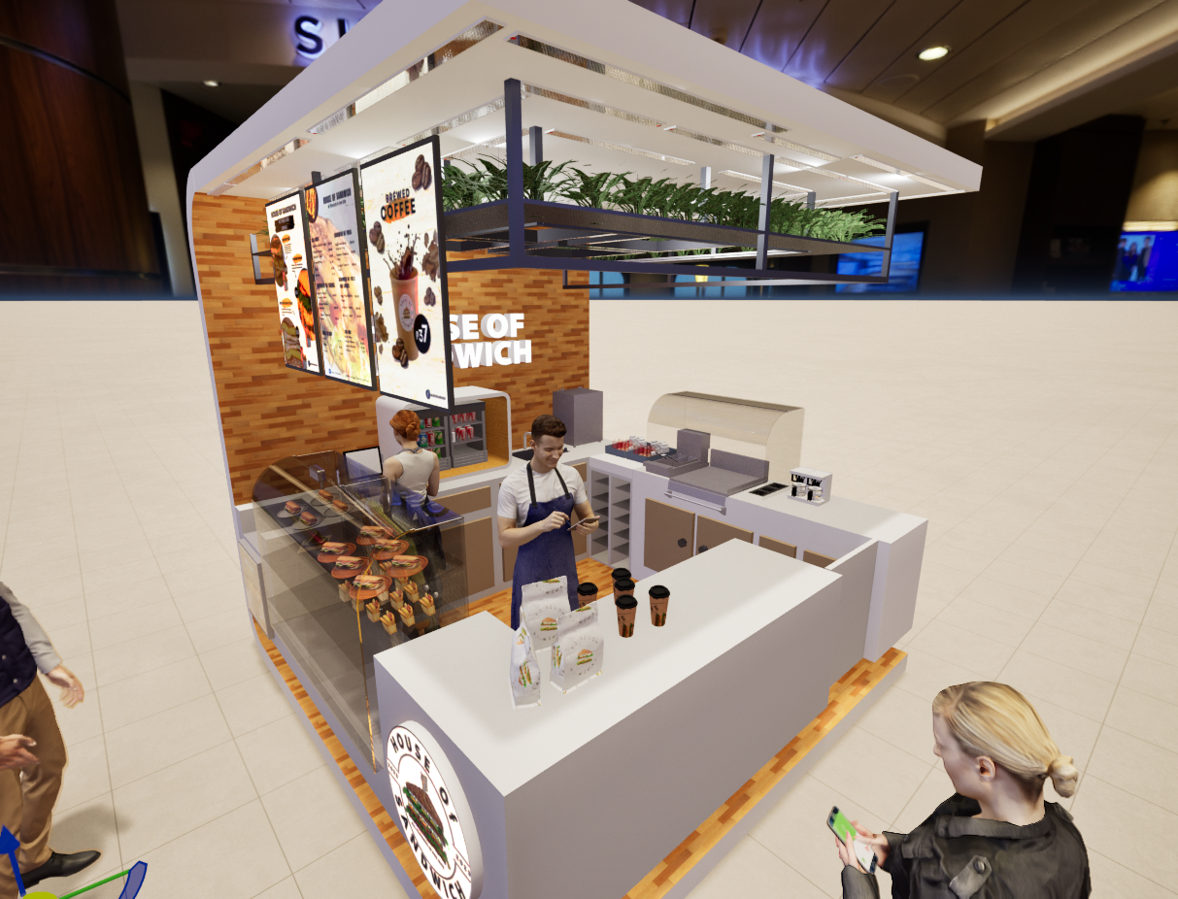

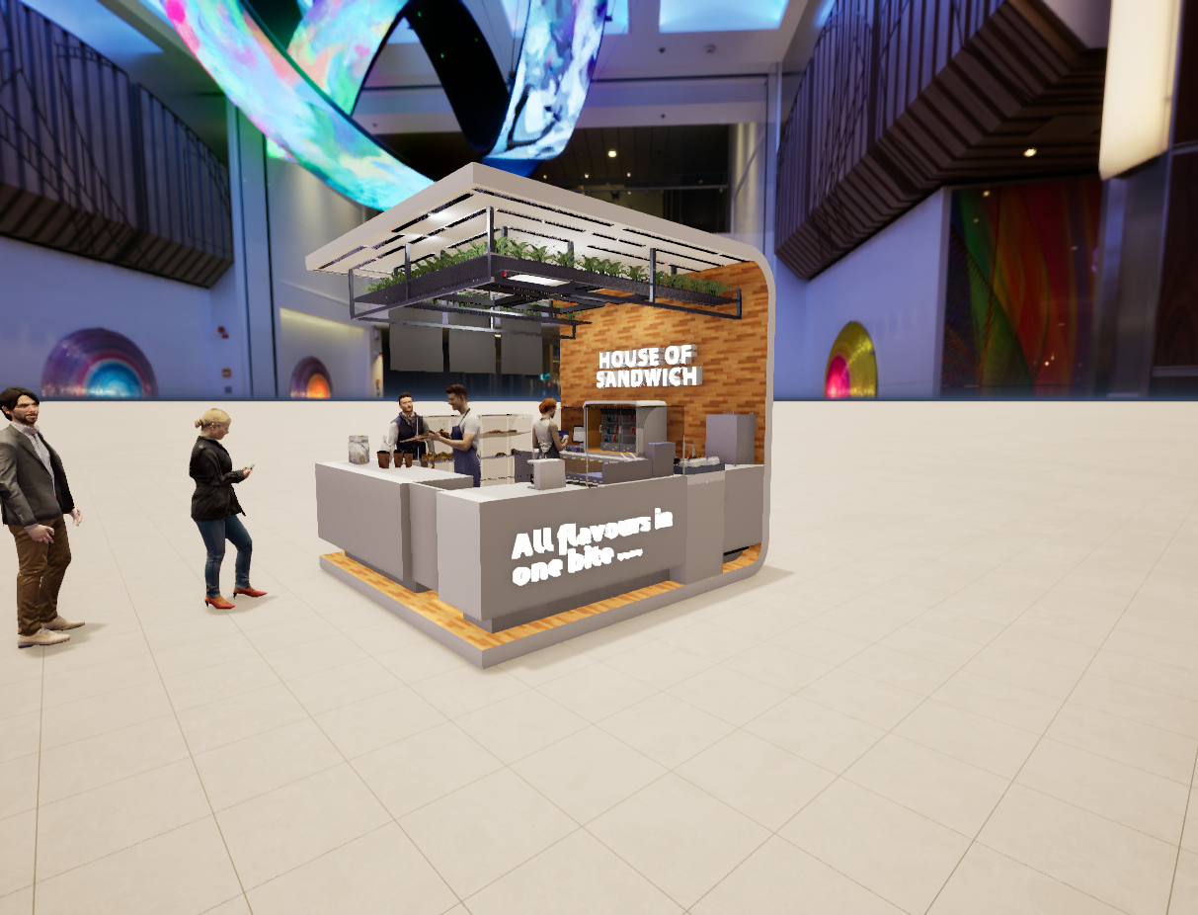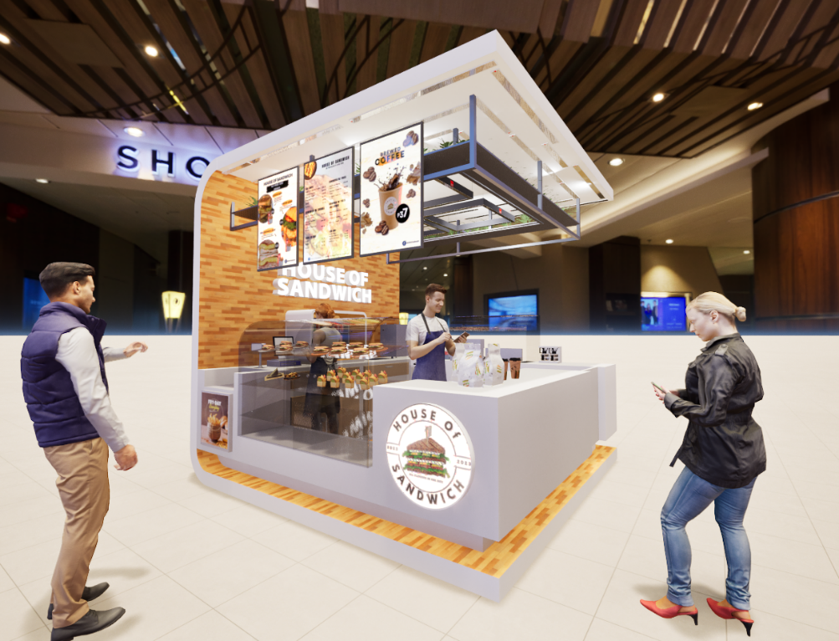

**c. Perspective View of the establishment**

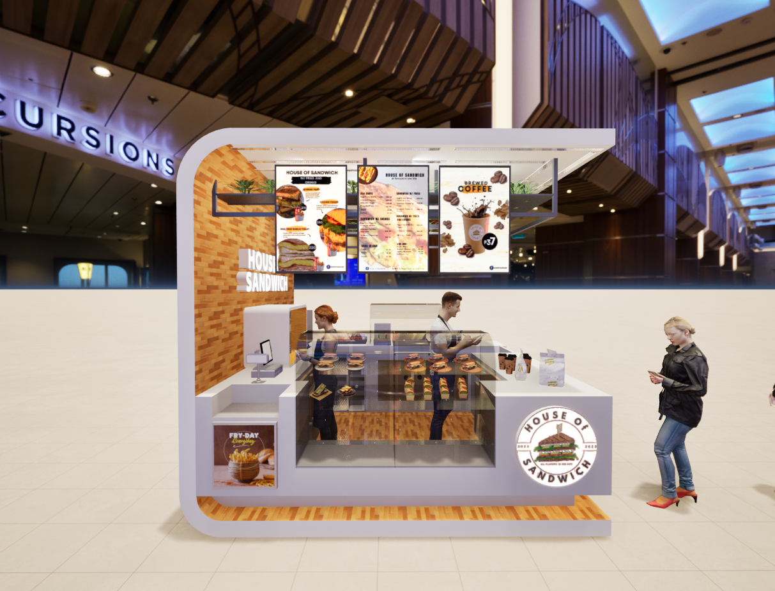

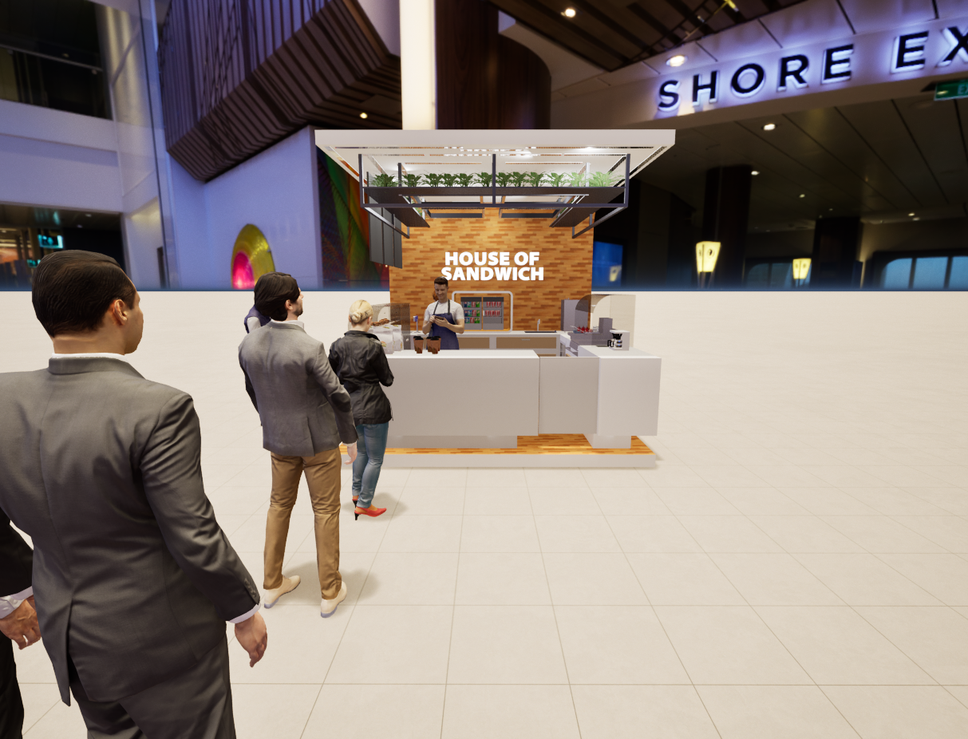

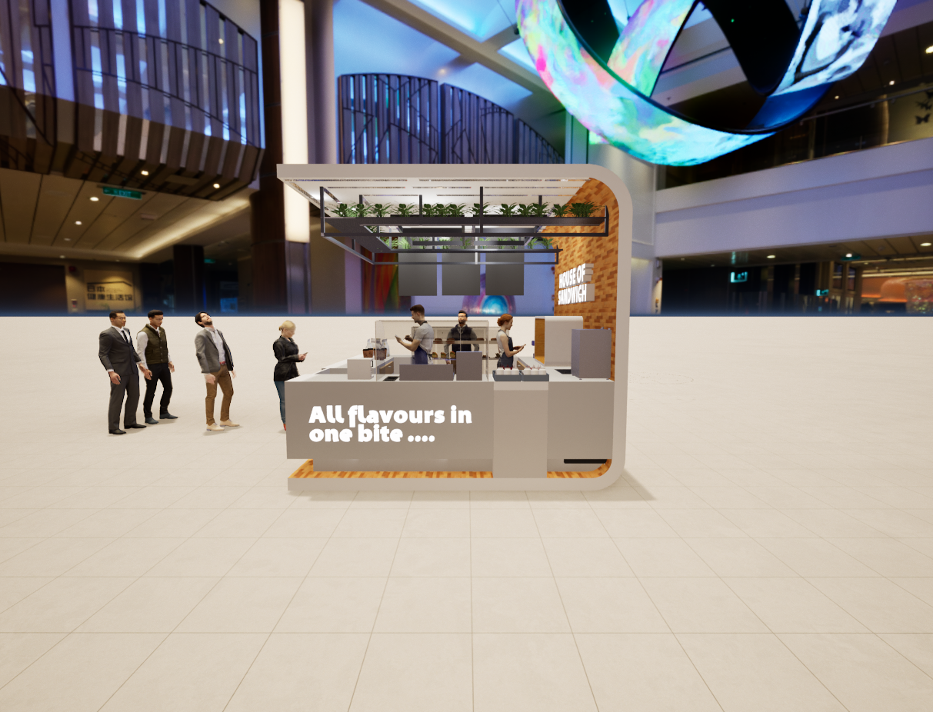

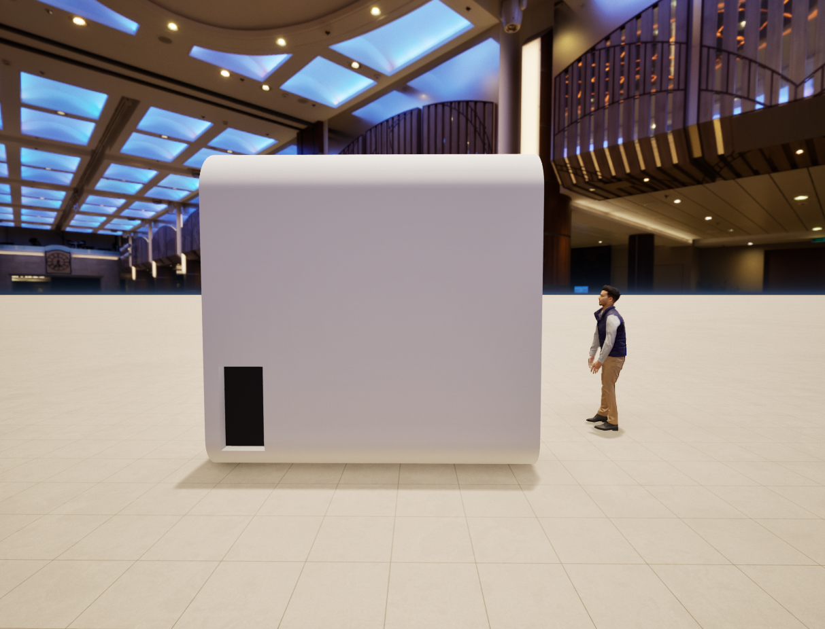

The inspiration of the theme is in the colors White, Brown black, and green because they represent cleanliness and it is very neutral in all colors. For lighting, it is a yellow or yellowish color to attract freshness and cover the imperfections of each product. The monthly Rental Fee Range to php. 15,000.00 Per month.

|  |  |  |  |
| --- | --- | --- | --- |
|  | **Day Process** | **Price** | **Total** |
| Construction materials and equipments |  |  | ₱400,000.00 |
| Construction fee (3P) | 3 weeks | ₱700.00 | ₱42,000.00 |
| Store Equipments |  |  | ₱146,710.39 |
| Product Materials |  |  | ₱647.00 |
| Store Materials |  |  | ₱2,075.00 |
| **TOTAL** |  |  | **₱591,432.39** |

**H. Source of Raw Materials and Supplies**

Our Business is House of Sandwich; it is a Korean sandwich consist various kind of ingredients. The ingredients and materials used is simple and easy to find. Our sources must be near in the nearest supermarkets, wet markets or merchandise store and online shop like shoppee and lazada that can be easy to find with affordable price and the good quality.

**I. Serving Procedures**

**Nine Gold Keys**

1. Smile and greet the customer Good Morning, Good Afternoon, Good Evening, or Good Day.
2. Take orders and do suggestive selling
3. Repeat order(s)
4. State the amount of purchase
5. Receive payment and give change if any.
6. Take the name of the customer
7. Prepare the order
8. Serve with tissue
9. Ask for repeat business.

**Total Experience time (TET)**

**If the Products are available in the Food Warmer:**

3 minutes and 30 seconds in total from taking orders up until presenting products with official receipt.

1. Waiting Time (90 seconds) from joing line up to punch of orders
2. Order taking time (25 seconds) from settled order up to open drawer
3. Cash Time (15 seconds) from open drawer up to close drawer
4. Expedite Time (70 seconds) assembling the products with take out item.
5. Receipt to Present Time (10 seconds) call out and present

**If the Products are not available in the food warmer:**

11 minutes in total from taking orders up until presenting products with official receipt.

1. Waiting Time (90 Seconds) from joing line up to punch of orders.
2. Order taking Time (25 seconds) from settled order up to open drawer.
3. Cash Time (15 Seconds) from open drawer up to close drawer.
4. Expedite Time (550 Seconds) from preparing up to assembling
5. Receipt to Present Time (10 seconds) call out and present.

**J. Cooking Preparation**

**Egg Fried Garlic Toast Sandwich**

Step 1: Put a Little amount of oil then Fry 3 pcs of Bacon for 90 seconds in 200°F and Beat 2 Eggs then cook into scrable egg for 60 seconds and 1 egg for sunny side up.

Step 2: Toast the 2 sliced Bread with butter.

Step 3: Transfer the toast bread into Wax Paper then Both sliced pour 30 grams of the Garlic Sauce add a leaf of Lettuce, Scramble Egg, sunny side up, Bacon, Scramble egg and another leaf of Lettuce.

Step 4: Wrap it and sealed using Tape in Both side then cut in Half. Do not cut the second Layer of wax paper to Support the positioning of Sandwich

Step 5: Put in the Packaging and add Melted Cheese on the Top.

**Chicken Tender Sandwich**

Step 1: pre-heat the oil into 350°F for 5 minutes. Deep-fry the Marinated and Prepared Chicken in 3 – 4 minutes until Golden Brown.

Step 2: In a Wax paper put 2 sliced Bread both pour 45 grams of Honey mustard Sauce add 4sliced tomato, 2 leaf of lettuce, 3 pieces of Chicken finger and 30 grams of shredded Carrot.

Step 3: Wrap and Sealed using tape both side then cut into Half. Do not cut the second later of wax paper to support the portioning of Sandwich

Step 4: Put in the Packaging.

**Gilgeori Sandwich**

Step 1: Fry 1 pc of Ham in a small amount of oil for 200°F.

Step 2: Beat 1 Egg add 125 grams of Shredded Carrot, 240 grams of Cabbage, 15 grams of scallion, and cook 30 seconds in each sides.

Step 3: Toast the 2 sliced bread with butter.

Step 4: In a Wax paper put Toast Bread pour 2 grams of ketchup in the piece of sliced bread and another 2 grams on the other sliced bread. Put Ham, Mixed Veggies in egg and Put a pinch of Sugar.

Step 5: Wrap and sealed using tape both side then cut into half. Do not cut the second Layer of Wax paper to support the Portioning of Sandwich.

**Brewed Coffee**

Step 1: Put the filter inside filter basket

Step 2: Put 1 scoop of fined coffee

Step 3: Pour 1 liter of water and wait for 5 minutes

Step 4: Remove the Coffee Filter when it has done brewing.

**K. Utilities**

**A.** Maynilad - Water

**B.** Meralco – Electricity

**C.** JRR trading - Waste Mangement

**D.** Malabanan Services – Sanitation

In operating our business, it is essential to have connections, so we are coordinating with the said companies above to ensure that House of Sandwich acquire the electricity, clean water, sanitation, trash and recycling that we need.

**L. Waste Disposal Management**

Our business is an eco-friendly business to ensure that House of Sandwich won't harm the environment we will have a proper waste disposal and Segregation of biodegradable to non-biodegradable trash will be implemented. The collection of waste in Sm under their policy is two- times a week and collected everyday in time of 3 pm and closing time of 9 pm in every store.